**About Page**

**About**

Mydison Limited was founded by owner and inventor Hsien-Hsiang Chiu, an expert in system analysis design who specializes in creating autonomous robots. His Magic iRIID invention won two gold medals at the 2014 Invention & New Product Exposition (INPEX), America's Largest Invention Show. The 2014 INPEX Jury Awards selected Magic iRIID for its top award in the [Computer](https://www.inpex.com/awards/2015/computer-15.aspx) and [Electrical/Electronics](https://www.inpex.com/awards/2015/electrical-15.aspx) categories. The technology behind Magic iRIID’s autonomous robotic video vision is patented in the U.S. and Canada. Mr. Hsien-Hsiang Chiu lives in Branchton, Ontario, Canada, where he is working on several of his own invention ideas in various fields.

**Mydison Limited Autonomous Robotic Research & Development:**

**iRIID: Gesture Interface Robot**

To see a demonstration of iRIID, view the short PowerPoint presentation in the video below:

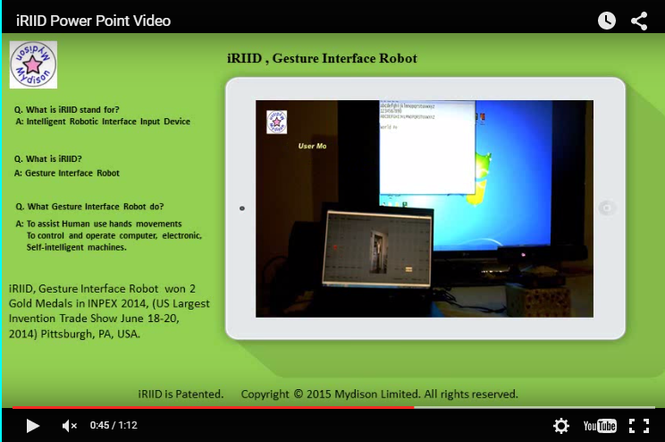

**Description:**

iRIID stands for Intelligent Robotic Interface Input Device. The device is an autonomous robot that recognizes and tracks hand movements and matches them to input commands that can operate and control computers, electrically-operated machines, or other smart machines. The iRIID Robot automatically measures the user’s body dimensions to establish a virtual computer interface before the user. Next, it instantly creates any virtual keyboard, or control panel, that the user requires. The user simply has to stand and gesture, without needing to wear any extra hardware, or to stand on a fixed location.

iRIID’s computer video vision reads the user’s hand movements in 3D XYZ dimensions (the three coordinate axes in three-dimensional space), before matching the user’s gestures to its virtual command keys mapping list. iRIID detects and executes the user's selection of virtual command keys to operate computer machines. With the easy-to-use virtual keyboard, there is no need to memorize any complex computer command keys on the part of the user. Visual feedback assists the user by displaying each key’s function.

The iRIID Gesture Interface Robot invention won two gold medals at the 2014 Invention & New Product Exposition (INPEX), America's Largest Invention Show. The 2014 INPEX Jury Awards selected Magic iRIID for its top award in the [Computer](https://www.inpex.com/awards/2015/computer-15.aspx) and [Electrical/Electronics](https://www.inpex.com/awards/2015/electrical-15.aspx) categories.

To contact Mr. Hsien-Hsiang Chiu, the inventor of iRIID and the Magic iRIID app, [send an email](mailto:hhchiu88@hotmail.com?Subject=iRIID%20Invention), or visit Mydison on Twitter at [@Mydison](http://www.twitter.com/Mydison).

**Home Page**

**Our Technology: Intelligent Robotic Interface Input Device (iRIID)**

Our award-winning technology, iRIID, is a **Gesture Interface Robot** that uses hand movements to operate and control your computer. This intelligent gesture interface robot uses a virtual interface, tracking the user’s hand gestures. With iRIID’s virtual interface, there is no need for physical controls like your computer’s mouse, keyboard, or other physical control interface.

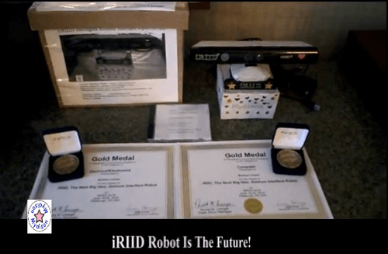

Our technology is the **winner of two Gold Medals at the 2014 INPEX Jury Awards** in Pittsburgh, PA. The Invention & New Product Exposition (INPEX), America's largest invention show, awarded iRIID gold medals in both the Computer and Electrical/Electronics categories as “the Next Big Idea.”

**New Microsoft Kinect App: Magic iRIID**

Magic iRIID is an app designed for use with Microsoft’s Kinect sensor. The technology behind iRIID creates a virtual user interface, using 3D XYZ space measurements (the three coordinate axes in three-dimensional space) to track hand gestures, and matches them to input commands that control your computer. It is unlike any other gesture technology software you may have tried before.

Magic iRIID’s true virtual user interface is one that you must try, and is available on a trial basis. [Download a free trial](https://www.mydison.com/Download.html) now to experience the virtual control provided by our app. Virtually controlling your computer with a hand gesture used to happen only in Sci-Fi movies, but the future is here with Magic iRIID.

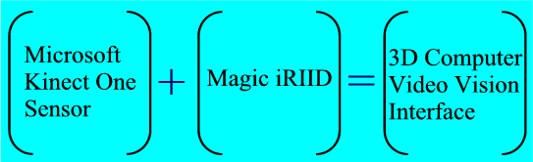

**The Simplest Method to Build a 3D Computer Video Vision Interface**

The video below demonstrates how easy it is to build a 3D computer video vision interface using Magic iRIID. In five easy steps, you can build an interface between your computer and an external monitor, allowing you to control your computer through simple hand gestures that use the interface’s virtual keyboard commands.

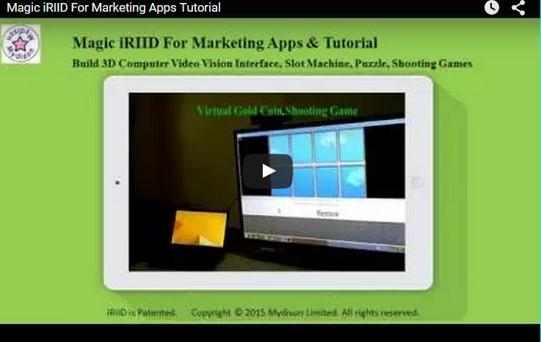

**What Magic iRIID Can Do:**

Magic iRIID instantly builds a 3D computer virtual interface for display on an external monitor, allowing you to control your computer through hand gestures. By interacting with Magic iRIID’s virtual interface, your hand movements click on virtual command keys for Microsoft Media Center, Windows Media Player, PowerPoint, Skype for Desktop, and your PC’s calculator program. Magic iRIID also supports the [free Windows PC Desktop 64-bit game samples](http://www.mydison.com/Apps.html#game) available on our Game Apps page.

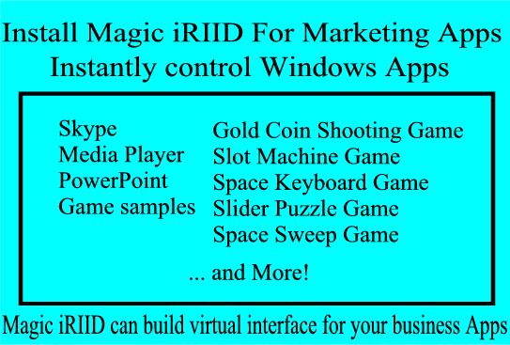

**Promote Your Products or Business Services with Magic iRIID**

Upgrade your business apps by interfacing them to the power of Magic iRIID’s 3D computer video vision. Magic iRIID can be an exciting addition to demonstrations of your business product or services at trade shows, or other presentations.

We can build a virtual interface for your business app. For more details, contact [support@Mydison.com](mailto:support@Mydison.com) for details.

[**Download Magic iRIID Apps for a Free 7-Day Trial**](https://www.mydison.com/Download.html)

Please enter your email address below and click “Submit” to receive a temporary password to use during your 7-day free trial of Magic iRIID:

[Input Your Email field]

[Submit button]

iRIID invention is patented.

**Opportunity Page**

**Business Opportunity: Free Virtual Interface Service**

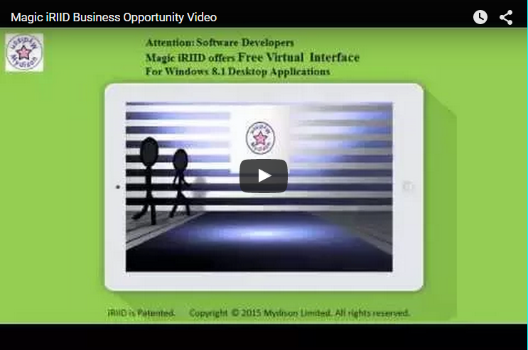

**Attention: Software Developers! We make iRIID available for use with your app. Read below for more information about this exciting business opportunity:**

iRIID offers software developers our Free Virtual Interface Service to create business opportunities for your app. If you have a Windows 8.1 desktop application, and would like a free virtual user interface for your app, contact our email support team at: [Support@Mydison.com](mailto:Support@Mydison.com).

Please complete the following steps to be considered for selection:

* Use the following subject line, along with your app’s name: “[Your App] Virtual Interface Application”

Include the following information in the body of your email:

* The purpose of you app, and its target user group
* A list of your app’s major functions and features
* The current number of users for your app
* If your app is free or paid

Our Virtual Interface Service is a free service. Mydison Limited owns all rights to Magic iRIID’s virtual interface, and we reserve the right to withdraw this free service at any time.

**Download Page**

**Download Magic iRIID Apps, User Manuals & Support**

We have several download packages for Magic iRIID to meet your needs: downloads to support marketing apps; Skype for Desktop; and a free trial version of Magic iRIID. Select a download from one of the three options on this page. When your download is complete, enter your email address below in order to receive a temporary password for your 7-day free trial.

[input email]

[submit button]

We have three download packages to support marketing apps, Skype, and a free trial version of Magic iRIID:

|  |  |
| --- | --- |
| [**Download 1: Free Trial Magic iRIID For Marketing Apps**](https://www.mydison.com/Files/MKT/setup.exe)  (Release date: July 22, 2015) |  |
| This download supports the use of Magic iRIID for marketing applications, and includes support for games. Promote your business services and products using Magic iRIID to interface with PowerPoint, media players, and Skype for dekstop. The Gold Coin game is included. | **Purchase full license** |
| Download [Magic iRIID for Marketing User Manual](https://www.mydison.com/Files/MKT/MGMKTUserManual.pdf) for Setup Instructions. | **License purchase required for each Kinect Sensor connected to 1 computer.** |
| [**Download 2: Free Trial Magic iRIID Virtual Phone Interface Program**](https://www.mydison.com/Files/VPI/setup.exe)  (Release date: June 25, 2015) |  |
| The software establishes a virtual keyboard that allows the user to control Skype for Desktop v7.5. Users can operate their computer’s Skype program to accept calls and video calls, dial out, make calls and video calls, all by using hand gestures. | **Purchase full license** |
| Download [Magic iRIID Virtual Phone Interface User Manual](https://www.mydison.com/Files/VPI/MagicIRIIDvpiUserManual.pdf) for Setup Instructions. | **License purchase required for each Kinect Sensor connected to 1 computer.** |
| [**Download 3: Free Trial Magic iRIID Program**](https://www.mydison.com/Files/setup.exe)  (Release date: May 12, 2015) |  |
| Magic iRIID is a new Kinect Software Application allowing users to control computers through hand gestures. The app’s interface displays virtual command keys that give users the ability to click remotely, by hand gesture, on the following Windows programs: Microsoft Media Center, Media Player, PowerPoint, and Windows calculator. | **Purchase full license** |
| Download [Magic iRIID User Manual](https://www.mydison.com/Files/MagicIRIIDUserManual.pdf) for Setup Instructions. | **License purchase required for each Kinect Sensor connected to 1 computer.** |

Or, [Email Us](mailto:Support@Mydison.com) to request both the free trial download and password:

Please use the following Subject line: Request Magic iRIID Apps Free Trial Download & Password

* Please include your Name and Email Address.
* We reply only to valid email addresses (Example:name@CompanyDomainName.com)

**iRIID Page**

**What Magic iRIID Can Do**:

* Magic iRIID automatically measures the user’s distance, and establishes the Virtual Interface in front of the user
* The Virtual Interface is established in front of the user, approximately 25 cm (approximately 10 inches) away.
* Magic iRIID calibrates the virtual keyboard used for controlling Windows applications.
* With the Virtual Interface directly in front, and a short distance away, the user can make hand movements within the virtual interface zone, providing the ability to select, push and click the keys on the virtual keyboard. The user is free to move within the virtual interface zone, without having to remain in a fixed position. There is no extra hardware for the user to wear.
* Magic iRIID displays visual feedback, assisting the user by displaying each key’s function.

Watch the video below to see a demonstration of Magic iRIID playing the Gold Coin App game, and see how you can shoot fireballs from your hand like Iron Man!.



**Many Uses for All Types of Users**

Magic iRIID is designed for a wide variety of uses that include business and pleasure. Gamers, Sci-Fi movie fans, business owners, and executives can all find potential uses for Magic iRIID:

* Trade show demonstrations and seminars
* Music and movie entertainment
* Art studios and academic settings
* Business conference settings
* PowerPoint presentations
* Product and service demonstrations, or video presentations
* Home office and home theater
* Party events

Magic iRIID is the best virtual interface program for people who love science fiction movies and want to control their computer in ways that used to exist only in Sci-Fi movies.

The imagination of Sci-Fi has now become reality!

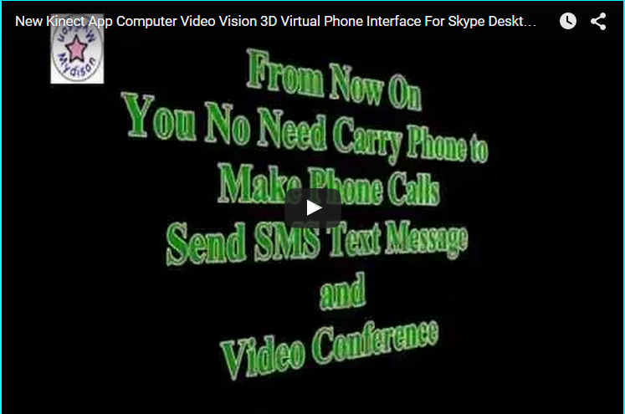

Magic iRIID is the new Kinect Software Application allowing users to control their computer through hand gestures. With Magic iRIID’s virtual keyboard interface, users can move their hands to “gesture click” on the virtual command keys for programs like: Microsoft Media Center, Windows Media Player, PowerPoint, Skype for Desktop, and Windows calculator.

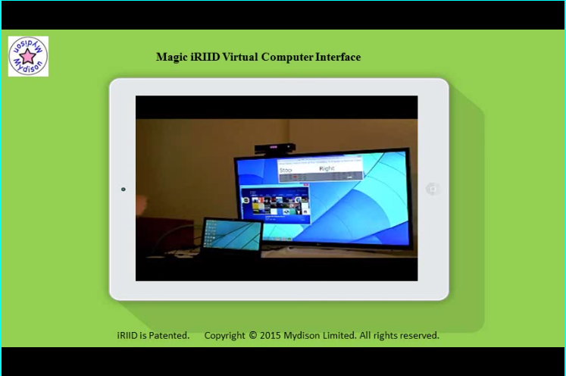

**Tutorial & Support:**

Magic iRIID is available for a free, 7-day trial. Download the free trial version directly from our Download page, or request it here via email.

To receive a temporary password for your 7-day free trial, please enter your email address below and click “Submit”:

[input email]

[submit button]

Or, [Email Us](mailto:Support@Mydison.com) to request both the free trial download and password. Please use the following Subject line: Request Magic iRIID Free Trial Download & Password

* Please include your Name and Email Address.
* We reply only to valid email addresses (Example:name@CompanyDomainName.com)

|  |
| --- |
| To submit a bug report, ask a question about Magic iRIID, send suggestions, or business proposals: [Email Support Team](mailto:Support@Mydison.com) |
| Download [Magic iRIID For Marketing User Manual](https://www.mydison.com/Files/MKT/MGMKTUserManual.pdf)  Download [Magic iRIID Virtual Phone Interface User Manual](https://www.mydison.com/Files/VPI/MagicIRIIDvpiUserManual.pdf)  Download [Magic iRIID User Manual](https://www.mydison.com/Files/MagicIRIIDUserManual.pdf) |
| Click to Visit - Join the Magic iRIID Community Forum for Magic iRIID community discussions, and more Magic iRIID info, including how to use the Virtual Computer Interface to control Skype, Windows Calculator, Media Center, Media Player, and PowerPoint programs. |

[Software developers: learn more about using our 3D virtual interface for your app](http://www.mydison.com/Opportunity.html#opportunity)

**Requirements Page**

**Hardware & Software Requirements:**

All Magic iRIID Apps Programs support 1 adult user (user height: 155cm - 195 cm, or 5’ 11” - 6’ 4”).

Reading distance: 1 m - 4.5 m (3 - 14 feet).

Magic iRIID requires a Kinect for Windows v2 sensor:

* You must already have a Kinect v2 sensor, or
* Xbox One Kinect sensor + the Kinect Adapter cable for Windows.

**iRIID virtual interface keys only can be accessed by the Kinect sensor!**

Download and run the **Kinect Configuration Verifier** tool to check your system:

<http://www.microsoft.com/en-us/kinectforwindows/develop/downloads-docs.aspx>

Computer Requirements:

1. 64-bit (x64) processor

2. Dual-core 3.1-GHz (2 logical cores per physical) or faster processor

3. 4 GB RAM

4. Graphics card that supports DirectX 11

5. 1 x USB 3.0 controller

6. Display Native Screen Resolution 1920 x 1080.

7. Web Camera

8. External Microphone

Software Requirements:

1. Windows 8.1

2. 64-bit

3. English version

4. Keyboard Layout Setting: US-English

5. Kinect SDK 2.0

6. .NET Framework 4.52+

**Apps Page**

Magic iRIID has several games and apps available for use with Magic iRIID

|  |  |  |
| --- | --- | --- |
| Release Date | **Free Online Game Apps List:**  All free games are Windows PC Desktop 64-bit games, and are supported by Magic iRIID’s virtual user interface.  Game sound - use Chrome and Firefox browser support  Windows PC game require a keyboard to play  or  Download Magic iRIID to be used with Kinect One Sensor | Publisher |
| July 22, 2015 | [Play Gold Coin Game](http://www.mydison.com/GC) | Mydison Limited |
| July 27, 2015 | [Play Space Sweep Mission Game](http://www.mydison.com/SS) | Mydison Limited |
| July 27, 2015 | [Play Slot Machine Game](http://www.mydison.com/SM) | Mydison Limited |
| July 27, 2015 | [Play Slider Puzzle Game](http://www.mydison.com/SP) | Mydison Limited |
| July 27, 2015 | [Play Space Keyboard Game](http://www.mydison.com/SK) | Mydison Limited |

# **Magic iRIID Apps Feature List:**

|  |  |  |
| --- | --- | --- |
|  | **Magic iRIID Apps List:** |  |
| (Release Date: July 22, 2015) | **Magic iRIID For Marketing Apps** |  |
| Description: | Virtual Interface for Marketing Apps  Using Magic iRIID marketing apps to promote your business   * Support Skype Virtual Phone Interface * Support Microsoft Virtual Media Player Interface * Support Microsoft Virtual PowerPoint Interface * Gold Coin Game, Space Sweep Game * Slot Machine Game * Slider Puzzle Game, Space Keyboard Game * Support Gold Coin Game Virtual Interface |  |
| (Release date: June 25, 2015) | **Magic iRIID Virtual Phone Interface App** |  |
| Description: | **Virtual Phone Interface for Skype**  **Build Skype Phone Interface In front of You!**  **Microsoft Skype For Desktop Program V 7.5**   * Receive & make phone calls * Receive & send video calls * Send text messages * Send SMS to other Skype users |  |
| (Release date: May 12, 2015) | **Magic iRIID App** |  |
| Description: | **Virtual Keyboard Interface to control:**  1. Microsoft Windows Media Center - watch movies or TV Shows  2. Microsoft Windows Media Player - play music,video, or picture slideshows.  3. Microsoft PowerPoint - business service or product presentations  4. Microsoft Windows Calculator - for mortgage, vehicle lease, or conversion calculations. |  |
| **Standard**  **Features** | **All Magic iRIID apps include the following features:**   * Windows display settings, customize color, teleport program between monitors. * Provide input protection, allow user to set password for locking gesture input access. * Magic iRIID has Hand-Sign function (hand grab action to hold virtual key) * Once you hold the virtual key, you can swing the hand in directions to enter same key. * Useful for repeating click on the same key, such as PowerPoint presentation functions. * Magic iRIID total tracking, allows user to move, walk or sit within sensor camera view. |  |